Citizens United
A WebQuest for 12th Grade Government

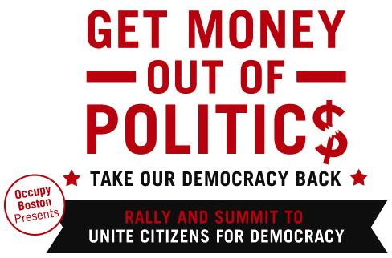
Introduction
Citizens United v. Federal Election Commission, (2010), was a landmark United States Supreme Court case filed by a political advocacy group “Citizens United” in which the Court held that the First Amendment prohibited the government from restricting independent political expenditures by corporations and unions. Essentially, the court found that corporations held the same fundamental Constitutional rights as a human being, since corporations were located in this country and made up of constitutionally protected citizens of this country. As a result of this ruling, large corporations with vested interests in a particular political party can pay for advertisements for or against a particular candidate, often times without the permission or even the knowledge of the candidate they are supporting. Your job today is to decide for yourself whether or not you agree with the ruling and to discover for yourself what potential negative and positive implications this ruling might have.

The Task
As you navigate through the WebQuest, you will want to answer the accompanying questions. Please place all answers to questions on a separate sheet of paper. This will be due tomorrow. You may find it helpful to follow the links below in the order they are presented, as that tends to ‘piece the story together’. Each link is given a name that both summarizes the purpose of the link and will correspond to which questions are associated with it on the second attachment.

WebQuest Links to follow

- What is “Citizens United” (three links)
http://www.citizensunited.org/who-we-are.aspx
http://www.citizensunited.org/what-we-do.aspx
http://www.citizensunited.org/fulfilling-our-mission.aspx

- Why are people upset by this decision?? (video…need headphones) http://www.storyofstuff.org/movies-all/story-of-citizens-united-v-fec/
- Former president Jimmy Carter gives his opinion http://www.politico.com//news/stories/0912/81087.html
- The American public’s take on the court’s decision http://www.politico.com//news/stories/0712/78647.html

- So how much money are we talking about? (view slideshow) http://www.opensecrets.org/news/2011/05/citizens-united-decision-profoundly-affects-political-landscape.html
- Who benefits the most?
http://www.opensecrets.org/news/2010/11/led-by-karl-rove-linked-groups-nonp.html
- What does the future look like for overturning/expanding this decision? http://www.prwatch.org/news/2013/02/11989/citizens-united-20-supreme-court-could-further-open-door-money-politics

